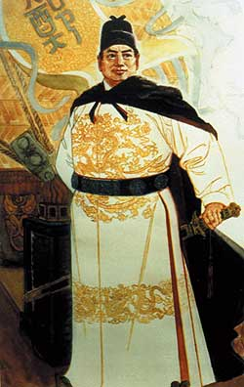

Admiral Zheng He

**New Inventions/technologies**

**Prince Henry, the Navigator**

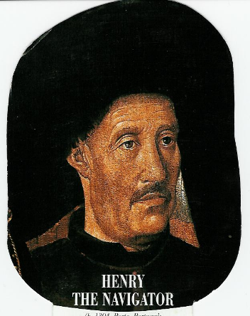

What country did he represent?

Importance

Motivations for Explorations

1.

2.

3.

4.

5.

6.

7.

What country did he represent?

Importance

What country did he represent?

What time period?

Where did he explore

How big were his ships?

How big were his expeditions?

Why did he stop?

Describe each:

G-d-

Gold-

Glory

Vasco da Gama

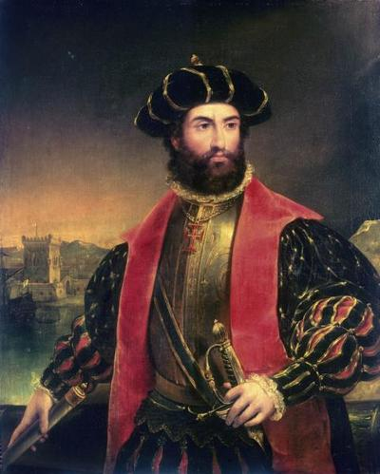

What country did he represent?

What did he explore/discover?

Importance

Impact

Ferdinand Magellan

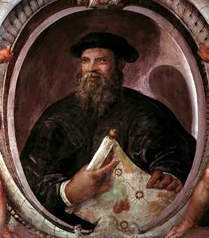

What country did he represent?

What did he explore/discover?

Impact

Christopher Columbus

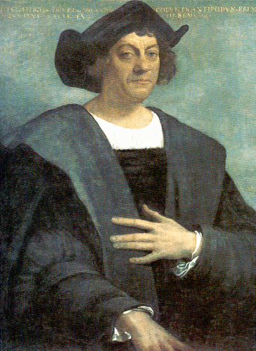

What country did he represent?

What did he explore/discover?

Importance

Impact

Hernan Cortes

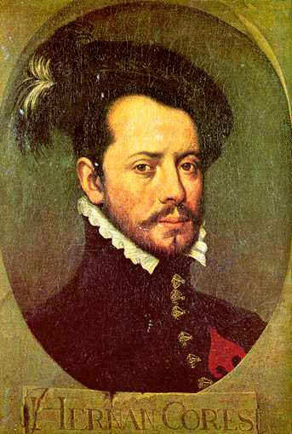

What country did he represent?

What did he explore/conquer?

Impact

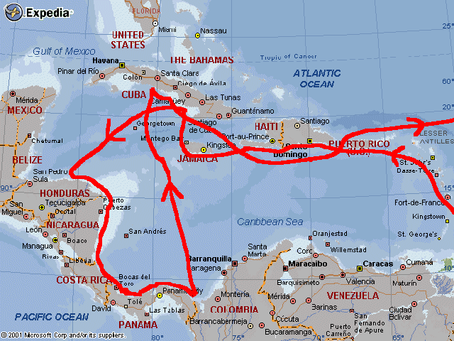

What country did he represent?

What did he explore/discover?

Importance

Impact

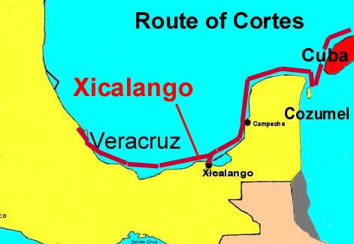

What country did he represent?

What did explore/conquer

Impact

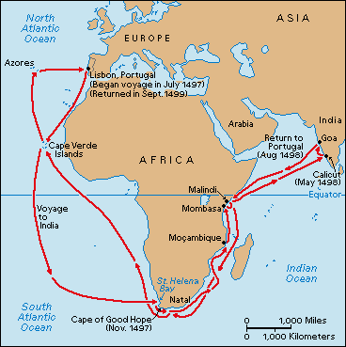

What country did he represent?

What did he explore?

Importance

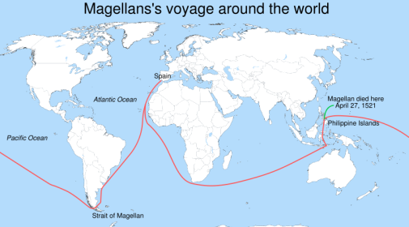

What country did he represent?

What did he explore?

Impact

Francisco Pizarro

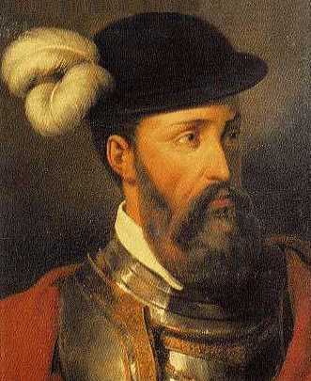

What country did he represent?

What did he explore/discover?

Impact

James Cook

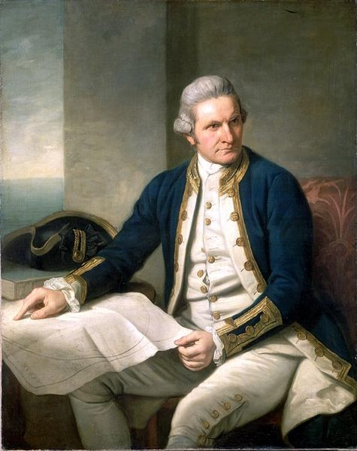

What country did he represent?

What did he explore/discover?

Impact

Samuel de Champlain

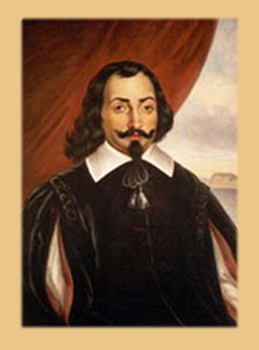

What country did he represent?

What did he explore/settle?

Impact

What led to Age of Exploration

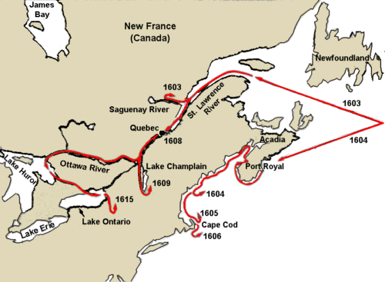

What country did he represent?

What did he explore/settle?

Impact

Most of the great early civilizations were in Asia and Africa Not much was happening in Europe, however close to Africa and Asia was Greece & then Rome

Ancient Greece

Ancient Rome

Crusades

Black Plague

Renaissance

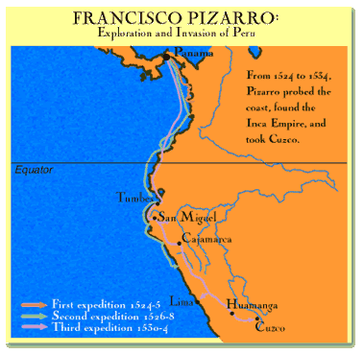

What country did he represent?

What did he explore/conquer?

Impact

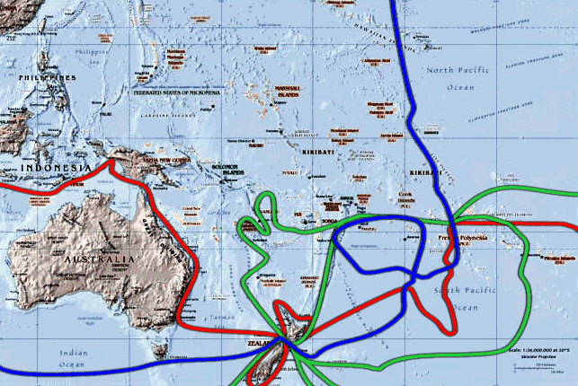

What country did he represent?

Voyage

Impact

John Cabot

Henry Hudson